班级Class_应电31984____姓名Name_____胡士龙_____学号ID__3080198107__________
项目名称＿低频RFID识读卡号项目（RDM6300模块）
Low Frequency RFID Reader Project
一、实验目的 Purposes
1. Understand the basic principle of ID carde；
2. Be familiar with the use of 125k card reading module。
二、实验设备 Modules
1. A piece of the Arduino Uno board；
2. RFID 125K module (RDM6300) one；
3. Low frequency ID card one
三、实验要求 Tasks
1. Requirements: understand the basic principle of ID card；
2. Implementation function: use Serial Monitor，to test the reading of ID card；
3. Experimental phenomenon: after swiping the card, the serial monitor displays the decimal card number of the ID card。
四、实验原理 Principle
1、ID card introduction
The full name of ID card is identification card. It is a non writable induction card with fixed number, mainly including EM format of Taiwan syris, American hid, Motorola and other ID cards. Like magnetic cards, ID cards only use the "card number". In addition to the card number, there is no confidentiality function in the card, and its "card number" is open and exposed. So ID card is "inductive magnetic card". The specification of ISO standard ID card is 85.6x54x0.80 ± 0.04mm (height / width / thickness). There are also some thick, thin or special-shaped cards on the market。
2、How ID cards work
The system consists of a card reader and a background controller. The working process is as follows：
- The card reader sends the carrier signal outward through the antenna, and the carrier frequency is 125kHz (thrc12);
- After the ID card enters the working area of the card reader, the resonant circuit composed of the inductive coil and capacitor in the card receives the carrier signal transmitted by the card reader, and the RF interface module of the chip in the card generates the power supply voltage, reset signal and system clock from this signal to "activate" the chip;
- The chip read control module modulates the data in the memory by phase modulation encoding and then sends it back to the card reader through the antenna inside the carrier.
- The card reader demodulates and decodes the received card return signal and sends it to the background computer；
五、实验内容 Content
1. Please explain the data format demodulated by RDM6300 reader.

Arduino控制器
RDM3600

Figure 1 system basic frame

2. Hardware design
Arduino uno3
Arduino programming is realized by using Arduino programming language (similar to C language) and Arduino development environment. The microcontroller on the board can be programmed by Arduino programming language, compiled into binary files and burned into the microcontroller. The software includes Arduino ide development environment and burning program. Arduino is cheap, can support third-party hardware, peripherals and libraries, and can expand your own projects more easily and quickly

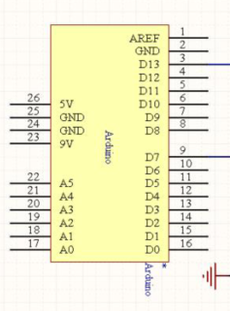
Figure 2 Arduino pin diagram

RDM6300
RDM6300 RDM6300 is a card reader module for 125KHz ID cards. It is used to read EM4100 compatible ID card information. It consists of a C8051F330 and a LM358D dual op amp.
Note: EM4100, 4200 cards are read-only. 5557/5567/EM4305 card is set to EM4100 format ID
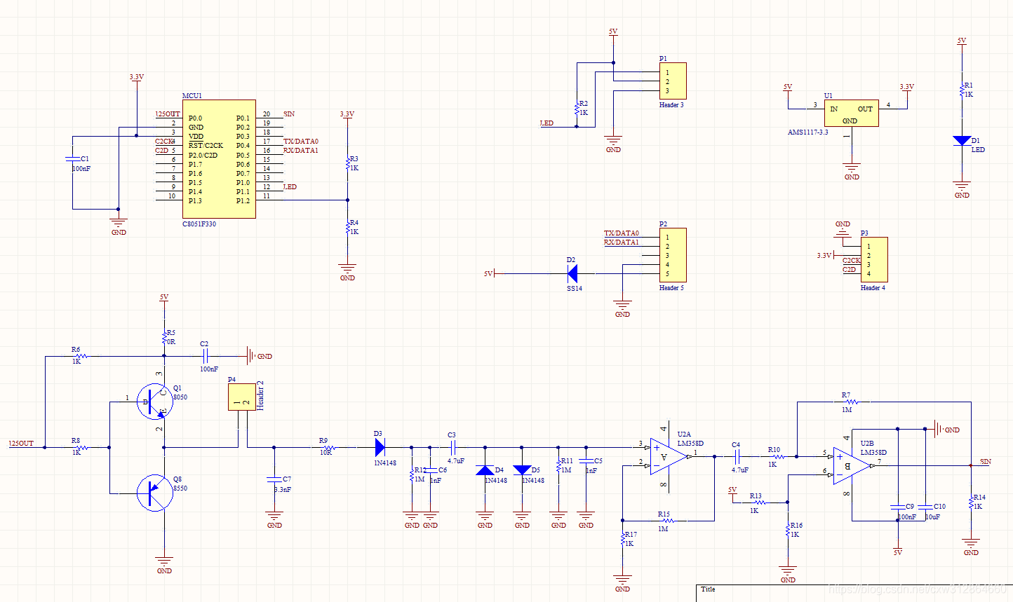
Figure 4 Schematic diagram of RDM6300

2. Programming
1  2  3  4  5  6  7  8  9  10  11  12  13  14  15  16  17  18  19  20  21  22  23  24  25  26  27  28  29  30 | #include <SoftwareSerial.h>  #include <RDM6300.h>  SoftwareSerial RFID(6, 8); // RX and TX  int Led=13;  uint8_t Payload[6]; // used for read comparisons  RDM6300 RDM6300(Payload);  void setup()  {  pinMode(Led, OUTPUT);  RFID.begin(9600); // start serial to RFID reader  Serial.begin(9600); // start serial to PC  }  void loop()  {  while (RFID.available() > 0)  {  digitalWrite(Led, HIGH);  uint8_t c = RFID.read();  //Serial.print(c,HEX);  if (RDM6300.decode(c)) {  for (int i=0; i < 5; i++){  Serial.print(Payload[i], HEX);  Serial.print(" ");  }  Serial.println();  }  }  digitalWrite(Led, LOW);  delay(100);  }

六、实验小结 Conclusion
Draw the circuit diagram of RDM6300 with the help of AD software, increase the understanding of RDM6300, find simpler programming in the open source repository of GITHUB, and realize the combination of chip and RDM6 300.

评语及评分：

